DEPARTMENT OF COMPUTER SCIENCE AND ENGINEERING VNRVJIET

Aim:
To implement a web-based checkout process using Java Servlets and JSP, allowing users to review their cart, enter shipping details, and complete the purchase.

Description:
This experiment demonstrates the implementation of a checkout process in a web application using Servlets and JSP. The system allows users to add products to a shopping cart and review the cart before placing an order.
The checkout process includes:
- Displaying cart items and total cost
- Collecting user details such as name, address, and phone number
- Processing the order using a servlet
- Storing order and item details in the database The application follows the MVC architecture, where:
  - JSP pages handle presentation
  - Servlets handle request processing
  - Java classes handle business logic and database interaction

Tags Used:
  - Java → Core programming language used to build the application logic
  - Servlets (javax.servlet) → Handle client requests and control application flow (Controller)
  - JSP (Java Server Pages) → Used to create dynamic web pages (View)
  - JDBC → Connects Java application to MySQL database
  - MySQL Database → Stores order and order item details
  - Apache Tomcat 9 → Web server used to deploy and run the application
  - HTML → Used to design basic structure of web pages
  - MVC Architecture → Separates application into Model, View, and Controller for better design
  - HttpSession → Stores user cart data temporarily during session
  - DAO (Data Access Object) → Handles database operations (insert, retrieve data)

Steps
Start Application
↓
User opens Products Page (products.jsp)
↓
User selects a product
↓ AddtoCartServlet is invoked
↓
Product is added to cart (stored in HttpSession)
↓
User navigates to Cart Page
↓
CartServlet retrieves cart data
↓

DEPARTMENT OF COMPUTER SCIENCE AND ENGINEERING VNRVJIET
Cart items and total amount displayed (cart.jsp)
↓
User clicks on Checkout
↓
Checkout Page (checkout.jsp) is displayed
↓
User enters shipping details (name, address, phone)
↓ CheckoutServlet is invoked
↓
OrderDAO processes the order
↓
Data stored in MySQL(orders table,order_items table)
↓
Cart is cleared from session
↓
Success Page (success.jsp) displayed
↓
User redirected to Products Page
↓ End
Code Implementation:
View:
- cart.jsp:
<%@ page language="java" contentType="text/html; charset=UTF-8" %>
<%@ page import="java.util.*, model.CartItem" %>
<html>
<head>
<title>My Cart</title>
</head>
<body>
<h2>My Cart</h2>
<table border="1">
<tr>
<th>Name</th><th>Price</th><th>Qty</th><th>Total</th>
</tr>
<%
List<CartItem> cart = (List<CartItem>) request.getAttribute("cart"); if(cart != null){
for(CartItem item : cart){
%>
<tr>
<td><%= item.getProductName() %></td>
<td><%= item.getPrice() %></td>
<td><%= item.getQuantity() %></td>
<td><%= item.getTotal() %></td>
</tr>

DEPARTMENT OF COMPUTER SCIENCE AND ENGINEERING VNRVJIET
<%
}
}
%>
</table>
<h3>Total: ₹ <%= request.getAttribute("total") %></h3>
<a href="view/checkout.jsp">Checkout</a>
</body>
</html>

checkout.jsp:
<%@ page language="java" contentType="text/html; charset=UTF-8" %>
<html>
<head>
<title>Checkout</title>
</head>
<body>
<h2>Checkout</h2>
<form action="../checkout" method="post">
Name: <input type="text" name="name" required><br><br> Address: <textarea name="address" required></textarea><br><br> Phone: <input type="text" name="phone" required><br><br>
<input type="submit" value="Place Order">
</form>
</body>
</html>

products.jsp:
<%@ page language="java" contentType="text/html; charset=UTF-8" %>
<html>
<head>
<title>Products</title>
</head>
<body>
<h2>Books</h2>
<form action="<%= request.getContextPath() %>/add-to-cart" method="post"> Java Programming - ₹500
<input type="hidden" name="name" value="Java Programming">
<input type="hidden" name="price" value="500">
<button>Add</button>
</form>
<br>
<form action="<%= request.getContextPath() %>/add-to-cart" method="post"> Data Structures - ₹400
<input type="hidden" name="name" value="Data Structures">
<input type="hidden" name="price" value="400">
<button>Add</button>
</form>
<br><br>
<a href="<%= request.getContextPath() %>/cart">Go to Cart</a>

DEPARTMENT OF COMPUTER SCIENCE AND ENGINEERING VNRVJIET
</body>
</html>

success.jsp:
<%@ page language="java" contentType="text/html; charset=UTF-8" %>
<html>
<head>
<title>Order Success</title>
</head>
<body>
<h2>✅ Order Placed Successfully!</h2>
<p>Thank you for your purchase.</p>
<a href="<%= request.getContextPath() %>/view/products.jsp"> Continue Shopping
</a>
</body>
</html>

Controller:
- AddtoCartServlet.java:
package controller;
import javax.servlet.ServletException; import javax.servlet.annotation.WebServlet; import javax.servlet.http.*;
import java.io.IOException; import java.util.*;
import model.CartItem; @WebServlet("/add-to-cart")
public class AddtoCartServlet extends HttpServlet { private static final long serialVersionUID = 1L;
protected void doPost(HttpServletRequest request, HttpServletResponse response) throws ServletException, IOException {
String name = request.getParameter("name");
double price = Double.parseDouble(request.getParameter("price")); HttpSession session = request.getSession();
List<CartItem> cart = (List<CartItem>) session.getAttribute("cart"); if (cart == null) cart = new ArrayList<>();
boolean found = false;
for (CartItem item : cart) {
if (item.getProductName().equals(name)) { item.setQuantity(item.getQuantity() + 1); found = true;
break;
}}
if (!found) {
cart.add(new CartItem(name, price, 1));
}
session.setAttribute("cart", cart); response.sendRedirect(request.getContextPath() + "/cart");
}}

DEPARTMENT OF COMPUTER SCIENCE AND ENGINEERING VNRVJIET

CartServlet.java:
package controller;
import javax.servlet.ServletException; import javax.servlet.annotation.WebServlet; import javax.servlet.http.*;
import java.io.IOException; import java.util.*;
import model.CartItem; @WebServlet("/cart")
public class CartServlet extends HttpServlet { private static final long serialVersionUID = 1L;
protected void doGet(HttpServletRequest req, HttpServletResponse res) throws ServletException, IOException {
HttpSession session = req.getSession();
List<CartItem> cart = (List<CartItem>) session.getAttribute("cart"); double total = 0;
if (cart != null) {
for (CartItem item : cart) { total += item.getTotal();
}
}
req.setAttribute("cart", cart); req.setAttribute("total", total);
req.getRequestDispatcher("view/cart.jsp").forward(req, res);
}}

CheckoutServlet.java:
package controller;
import javax.servlet.ServletException; import javax.servlet.annotation.WebServlet; import javax.servlet.http.*;
import java.io.IOException; import java.util.*;
import model.*; @WebServlet("/checkout")
public class CheckoutServlet extends HttpServlet { private static final long serialVersionUID = 1L;
protected void doPost(HttpServletRequest req, HttpServletResponse res) throws ServletException, IOException {
String name = req.getParameter("name"); String address = req.getParameter("address"); String phone = req.getParameter("phone"); HttpSession session = req.getSession();
List<CartItem> cart = (List<CartItem>) session.getAttribute("cart"); if (cart == null || cart.isEmpty()) {
res.sendRedirect("cart"); return;
}
OrderDAO dao = new OrderDAO();

DEPARTMENT OF COMPUTER SCIENCE AND ENGINEERING VNRVJIET
dao.saveOrder(name, address, phone, cart); session.removeAttribute("cart"); req.setAttribute("message", "Order placed successfully!");
req.getRequestDispatcher("view/success.jsp").forward(req, res);
}
}

Model:
- CartItem.java: package model; public class CartItem {
private String productName; private double price; private int quantity;
public CartItem(String productName, double price, int quantity) { this.productName = productName;
this.price = price; this.quantity = quantity;
}
public String getProductName() { return productName; } public double getPrice() { return price; }
public int getQuantity() { return quantity; } public void setQuantity(int quantity) {
this.quantity = quantity;
}
public double getTotal() { return price * quantity;
}}
- DBConnection.java: package model; import java.sql.*;
public class DBConnection {
public static Connection getConnection() { try {
Class.forName("com.mysql.cj.jdbc.Driver"); return DriverManager.getConnection(
"jdbc:mysql://localhost:3306/db?useSSL=false&serverTimezone=UTC", "root",
"root@123"
);
} catch (Exception e) { e.printStackTrace(); return null;
}}}
- OrderDAO.java: package model; import java.sql.*; import java.util.*;
public class OrderDAO {

DEPARTMENT OF COMPUTER SCIENCE AND ENGINEERING VNRVJIET
public void saveOrder(String name, String address, String phone, List<CartItem> cart) { double total = 0;
for (CartItem item : cart) { total += item.getTotal();
}
try (Connection con = DBConnection.getConnection()) {
String sql = "INSERT INTO orders(name,address,phone,total_amount) VALUES(?,?,?,?)";
PreparedStatement ps = con.prepareStatement(sql, Statement.RETURN_GENERATED_KEYS);
ps.setString(1, name); ps.setString(2, address); ps.setString(3, phone); ps.setDouble(4, total); ps.executeUpdate();
ResultSet rs = ps.getGeneratedKeys(); int orderId = 0;
if (rs.next()) {
orderId = rs.getInt(1);
}
String itemSql = "INSERT INTO order_items(order_id,product_name,price,quantity) VALUES(?,?,?,?)";
PreparedStatement ps2 = con.prepareStatement(itemSql); for (CartItem item : cart) {
ps2.setInt(1, orderId);
ps2.setString(2, item.getProductName()); ps2.setDouble(3, item.getPrice()); ps2.setInt(4, item.getQuantity()); ps2.executeUpdate();
}
} catch (Exception e) { e.printStackTrace();
} }}

TABLES IN DATABASE:
use db;
CREATE TABLE orders (
order_id INT AUTO_INCREMENT PRIMARY KEY, name VARCHAR(100),
address TEXT,
phone VARCHAR(15),
total_amount DOUBLE,
order_date TIMESTAMP DEFAULT CURRENT_TIMESTAMP
);
CREATE TABLE order_items (
id INT AUTO_INCREMENT PRIMARY KEY,
order_id INT,
product_name VARCHAR(100), price DOUBLE,

DEPARTMENT OF COMPUTER SCIENCE AND ENGINEERING VNRVJIET
quantity INT,
FOREIGN KEY (order_id) REFERENCES orders(order_id) ON DELETE CASCADE
);
SELECT * FROM orders; SELECT * FROM order_items; OUTPUT:
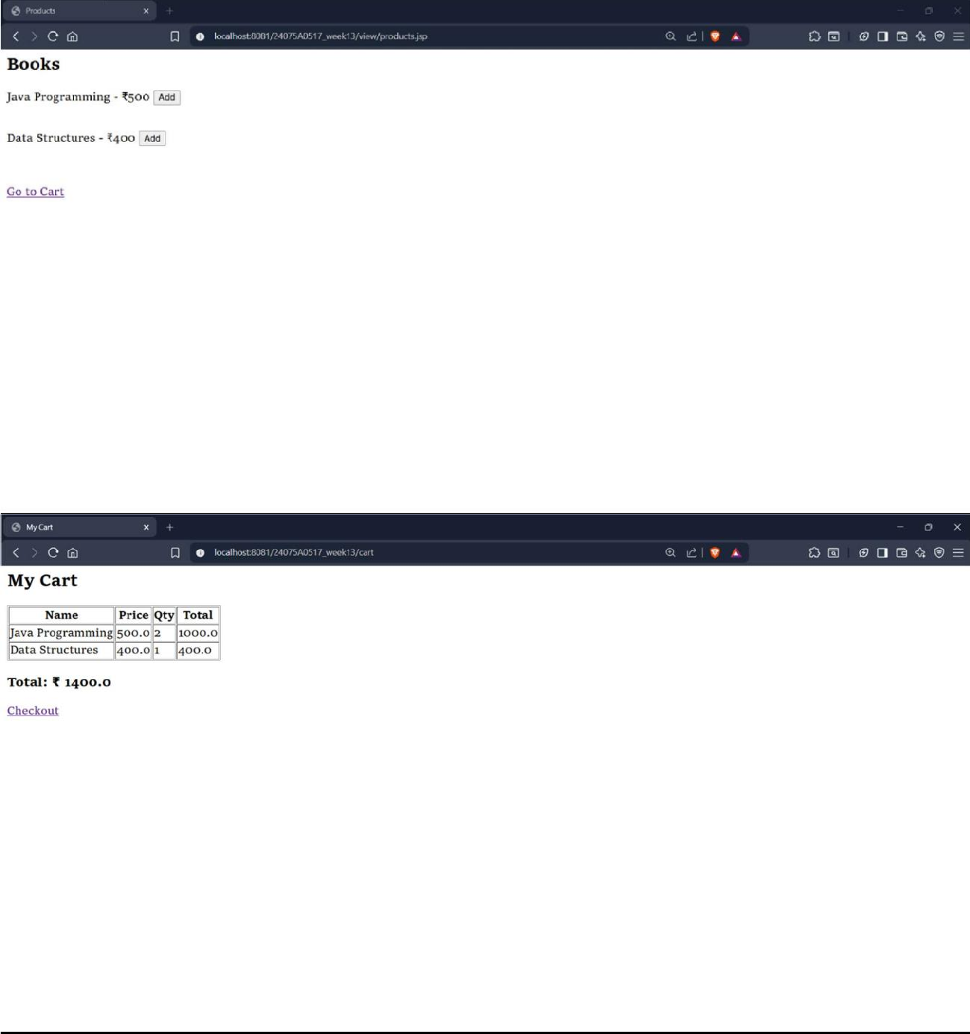

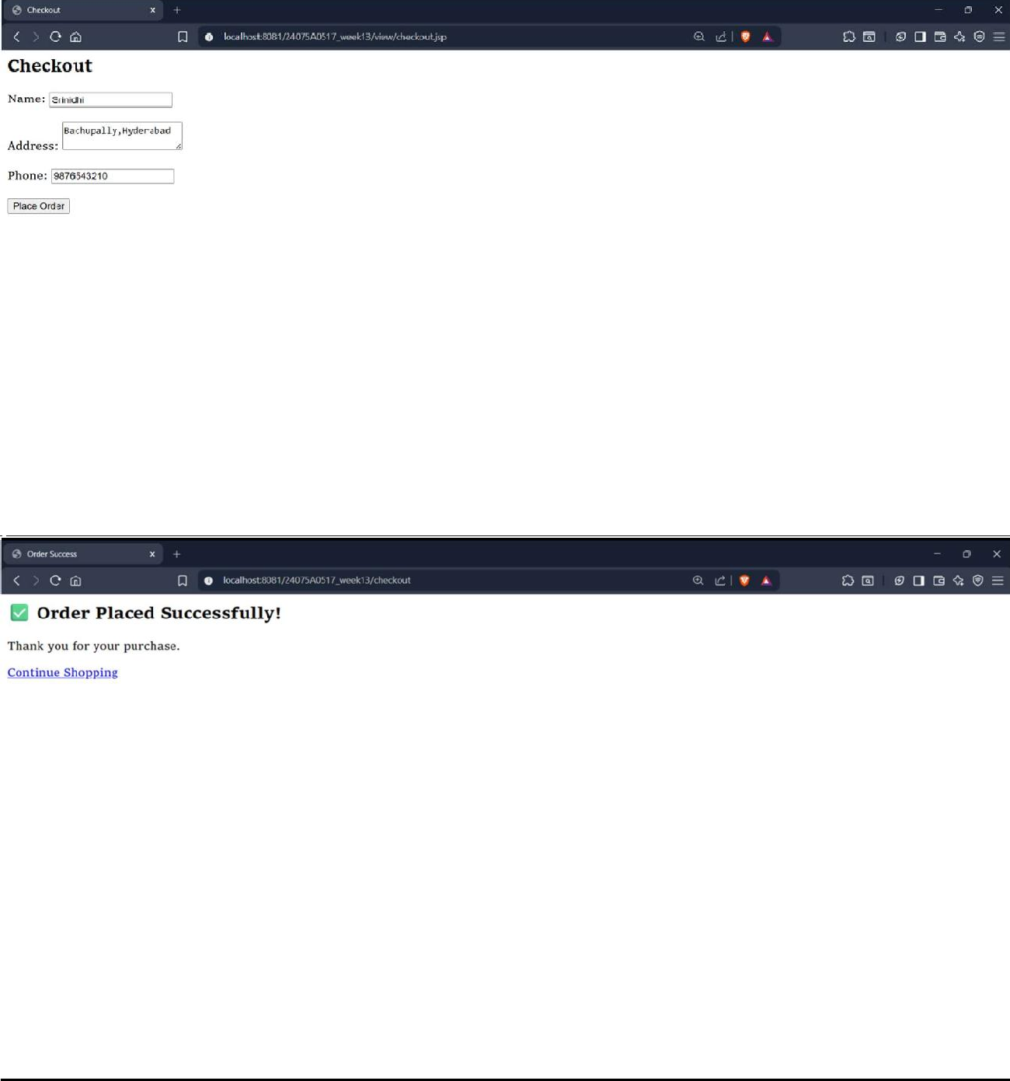
DEPARTMENT OF COMPUTER SCIENCE AND ENGINEERING VNRVJIET

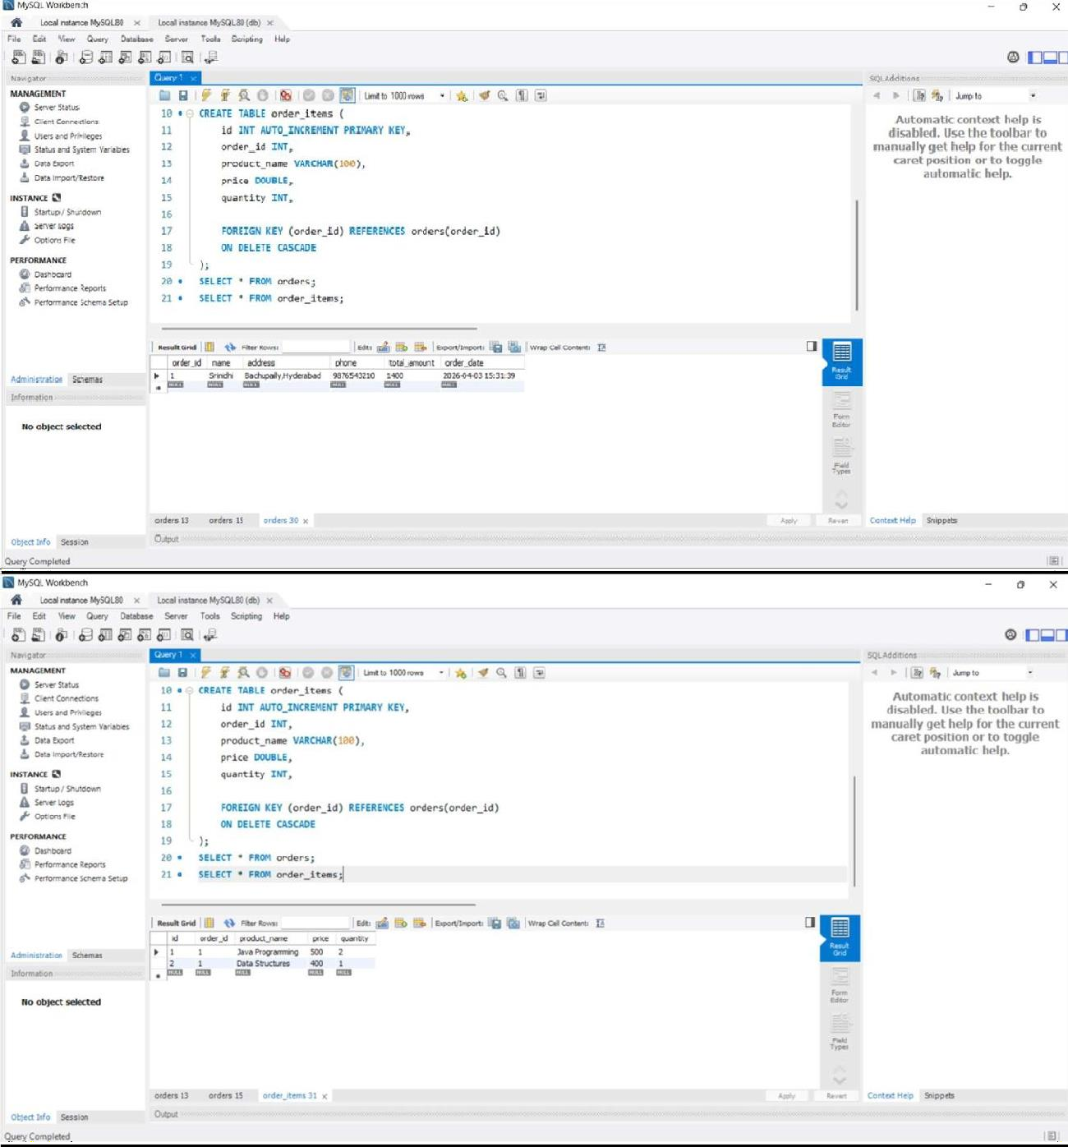
DEPARTMENT OF COMPUTER SCIENCE AND ENGINEERING VNRVJIET

